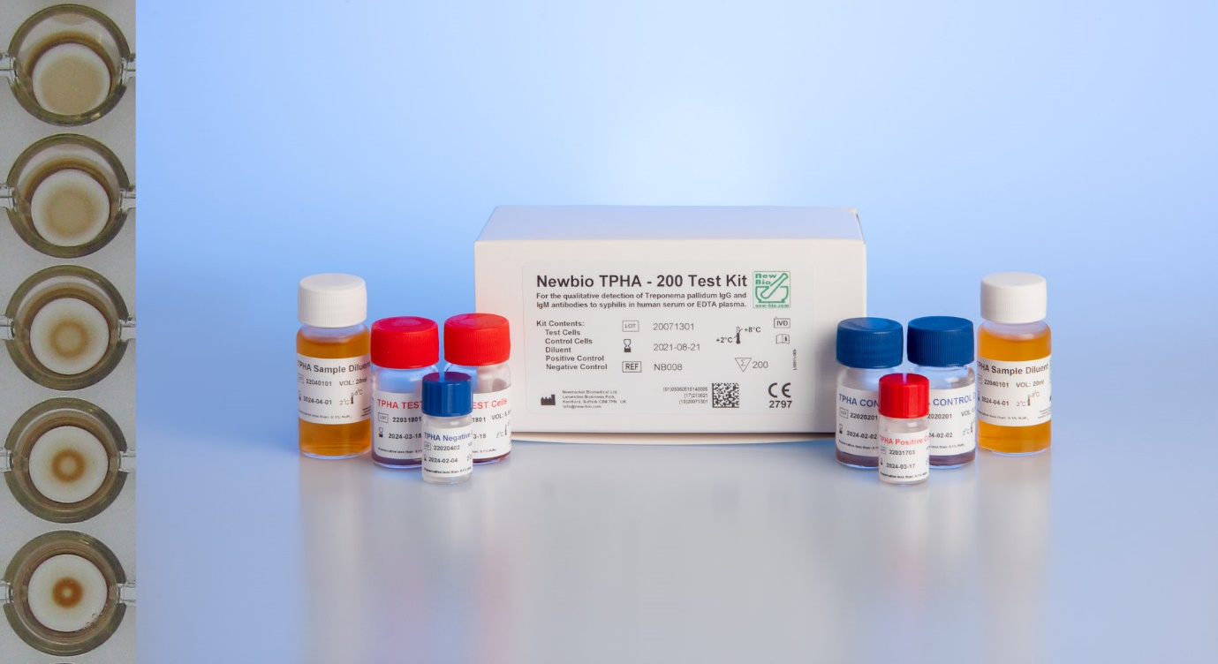

PRINCIPLE OF THE TPHA TEST

NewBio TPHA is a passive particle agglutination assay for the qualitative detection of IgG and IgM antibodies to Treponema pallidum in human serum, EDTA plasma, or CSF and to determine the titre level of the samples.

NewBio TPHA uses preserved avian erythrocytes coated with extracted antigens of T.pallidum (Nichols strain). Specific antibodies present in a sample of plasma or serum bind to these antigens when the sample is incubated with the particles. This causes the particles to agglutinate, then settle to form a characteristic pattern in the test well.

Non-specific reactions are eliminated by the use of absorbents. The assay is run and interpreted manually.

SPECIFICITY

A study with 1248 syphilis negative EDTA plasma samples showed 99.92% specificity (95% confidence interval 99.55-100.0%)

SENSITIVITY

A study with 205 syphilis positive samples (48 EDTA plasma and 157 sera) showed 100% sensitivity (95% confidence interval 98.22-100.0%)

LIMIT OF DETECTION

NewBio TPHA has an expected limit of detection of ≤0.1 IU/mL against the WHO 1st IS for human syphilitic plasma IgG NIBSC code: 05/122.

KEY FEATURES

* Quality Assured - 25 years experience
* Ready to use stable liquid reagents
* 24 months shelf life
* Qualitative and titration protocols
* Results ready in 45 minutes
* IVDR Certified
* Manual reading
* Convenient kit sizes all with control cells

NEWBIO TPHA 200 TEST KIT

PRODUCT NO: NB008

QUANTITY: 200 Tests

STABILITY: 24 months @ 2-8°C

NEWBIO TPHA 1000 TEST KIT

PRODUCT NO: NB009

QUANTITY: 1000 Tests

STABILITY: 24 months @ 2-8°C

NEWBIO TPHA 100 TEST KIT

PRODUCT NO: NB007

QUANTITY: 100 Tests

STABILITY: 24 months @ 2-8°C

NEWBIO TPHA 100 TESTS

* Haemagglutination assay for syphilis
* Native antigen and avian erythrocytes
* All reagents ready to use.
* TPHA Test cells  
  TPHA Control cells  
  TPHA Diluent  
  TPHA Negative control  
  TPHA Positive control
* Simple protocol: 1 x 45 minute incubation
* Manual
* Only requires 10 µL sample
* Serum, EDTA Plasma, CSF

NEWBIO TPHA 200 TESTS

* Haemagglutination assay for syphilis
* Native antigen and avian erythrocytes
* All reagents ready to use.
* TPHA Test cells  
  TPHA Control cells  
  TPHA Diluent  
  TPHA Negative control  
  TPHA Positive control
* Simple protocol: 1 x 45 minute incubation
* Manual
* Only requires 10 µL sample
* Serum, EDTA Plasma, CSF

NEWBIO TPHA 1000 TESTS

* Haemagglutination assay for syphilis
* Native antigen and avian erythrocytes
* All reagents ready to use.
* TPHA Test cells  
  TPHA Control cells  
  TPHA Diluent  
  TPHA Negative control  
  TPHA Positive control
* Simple protocol: 1 x 45 minute incubation
* Manual
* Only requires 10 µL sample
* Serum, EDTA Plasma, CSF